|  |  |
| --- | --- |
| **Name**: Konika Khurana | **UID**:23BCS12925 |
| **Branch**: CSE | **Section**: 23 BCS_FS 622-A |
| **Semester**: 5 | **Date of Performance**: 26/08/2025 |
| **Subject**: FULL STACK-LAB | **Subject Code**: 23CSP-339 |

**Practice 1:**

# Index.html

<!DOCTYPE html>

<html lang="en">

<head>

<meta charset="UTF-8">

<meta name="viewport" content="width=device-width, initialscale=1.0">

<title>Live Character Counter for Textarea</title>

<style> body { font-family: Arial, sans-serif; margin: 20px;

}

.container { border: 1px solid #000; padding: 15px; margin-bottom: 20px; width: 500px;

} textarea { width: 100%; height: 100px; padding: 10px; font-size: 16px; resize: none;

}

.counter { margin-top: 10px; font-weight: bold;

}

</style>

</head>

<body>

<div class="container">

<h3>Live Character Counter</h3>

<textarea id="textInput" placeholder="Start typing..."></textarea>

<div class="counter">Characters: <span id="charCount">0</span></div>

</div>

# Script.js

<!-- Link external JS file -->

<script src="script.js"></script>

</body>

</html>

const textarea = document.getElementById("textInput"); const charCount = document.getElementById("charCount");

textarea.addEventListener("input", () => { charCount.textContent = textarea.value.length;

});

**OUTPUT:**

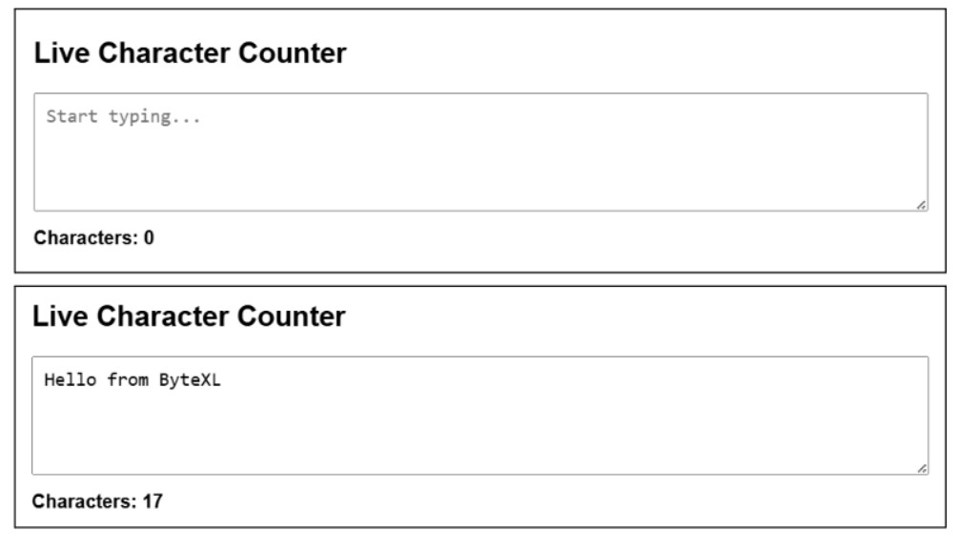

**PRACTICE 2:**

# Index.html

<!DOCTYPE html>

<html lang="en">

<head>

<meta charset="UTF-8">

<meta name="viewport" content="width=device-width, initial-scale=1.0">

<title>Dynamic Product Filter</title>

<style> body { font-family: Arial, sans-serif; margin: 20px;

}

.container { border: 1px solid #333; padding: 15px; margin-bottom: 20px;

width: 500px;

} select { padding: 6px; font-size: 16px; margin: 10px 0 20px 10px;

}

.product-list { display: flex; flex-direction: column; gap: 10px;

}

.product { border: 1px solid #ccc; padding: 10px; border-radius: 5px;

font-size: 16px;

}

</style>

</head>

<body>

<div class="container">

<h2>Product List</h2>

<!-- Dropdown Filter -->

<label for="categoryFilter"><b>Filter by Category:</b></label>

<select id="categoryFilter">

<option value="all">All</option>

<option value="clothing">Clothing</option>

<option value="electronics">Electronics</option>

<option value="books">Books</option>

</select>

<!-- Product List -->

<div class="product-list" id="productList">

<div class="product" data-category="clothing">T-Shirt</div>

<div class="product" data-category="clothing">Jeans</div>

<div class="product" data-category="electronics">Headphones</div>

<div class="product" data-category="electronics">Smartphone</div>

<div class="product" data-category="books">Novel</div>

<div class="product" data-category="books">Cookbook</div>

</div>

</div>

<!-- External JS -->

<script src="script.js"></script>

</body>

</html>

# script.js

const categoryFilter = document.getElementById("categoryFilter"); const products = document.querySelectorAll(".product");

categoryFilter.addEventListener("change", () => {

const selectedCategory = categoryFilter.value;

products.forEach(product => { if (selectedCategory === "all" || product.dataset.category === selectedCategory) { product.style.display = "block";

} else {

product.style.display = "none";

}

});

});

OUTPUT:

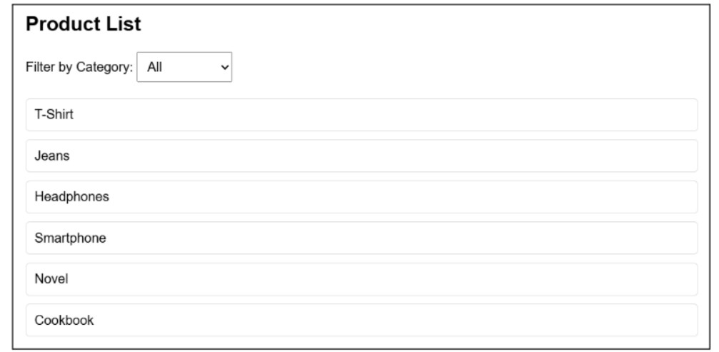

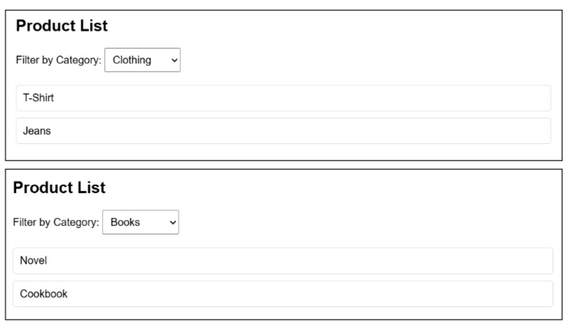

**PRACTICE 3:**

# index.html

<!DOCTYPE html>

<html lang="en">

<head>

<meta charset="UTF-8">

<meta name="viewport" content="width=device-width, initial-scale=1.0">

<title>SVG Drawing Tool</title>

<style> body { font-family: Arial, sans-serif; margin: 20px;

}

.container { border: 1px solid #333; padding: 15px; margin-bottom: 20px;

width: 600px;

} svg { border: 1px solid black; background: #f9f9f9; width: 100%; height: 400px;

cursor: crosshair;

}

</style>

</head>

<body>

<div class="container">

<h2>SVG Drawing Tool</h2>

<svg id="drawingCanvas"></svg>

</div>

<!-- Link External JS -->

<script src="script.js"></script>

</body>

</html>

**script.js** const svg = document.getElementById("drawingCanvas");

let drawing = false;

let currentPath = null;

svg.addEventListener("mousedown", (e) => {

drawing = true;

// Create a new path element

currentPath = document.createElementNS("http://www.w3.org/2000/svg", "path"); currentPath.setAttribute("stroke", "blue"); currentPath.setAttribute("stroke-width", "2");

currentPath.setAttribute("fill", "none");

// Start path at mouse position const x = e.offsetX; const y = e.offsetY; currentPath.setAttribute("d", `M ${x} ${y}`);

svg.appendChild(currentPath);

});

svg.addEventListener("mousemove", (e) => {

if (!drawing) return;

const x = e.offsetX; const y = e.offsetY;

// Append line segments as the mouse moves let d = currentPath.getAttribute("d");

currentPath.setAttribute("d", `${d} L ${x} ${y}`);

});

svg.addEventListener("mouseup", () => {

drawing = false;

});

**OUTPUT**:

